SDM COLLEGE OF ENGINEERING AND TECHNOLOGY,
Dharwad-580002
An autonomous Institution affiliated to
Visvesvaraya Technological University, Belgaum – 590018



Department of Electronics and Communication Engineering

A Synopsis on Minor Project-1 entitled

“SELF BALANCING ROBOT USING ESP32”

Submitted by
GURUPRASAD YADAV - 2SD22EC023
MEENAPPA TARANALLI - 2SD22EC038
MANOJ HALAPETI - 2SD22EC037
OM V HIREMATH - 2SD22EC047
Students of 5thSemester,
Bachelor of Engineering in Electronics and Communication.

Under the Guidance of

Prof. SUMANGALA BHAVIKATTI.
Designation : Assistant Professor, Dept. of ECE

INTRODUCTION:

The robot will be equipped with a variety of sensors, including an accelerometer and gyroscope. These sensors will measure the robot's orientation and angular velocity. The data from these sensors will be processed by the ESP32 microcontroller to determine the robot's state and calculate the required motor speeds to maintain balance. The motor driver will control the DC motors that power the robot's wheels. By adjusting the speed and direction of the motors, the robot can be controlled to maintain its balance. A user interface will be developed to allow users to interact with the robot. This interface may include a mobile app or a web-based interface. Users will be able to control the robot's movement and view its status.
The project is expected to provide valuable experience in robotics, electronics, and software development. It will also demonstrate the capabilities of the ESP32 microcontroller and the potential applications of self-balancing robots.

OBJECTIVES OF THE PROJECT:

This project aims to develop a self-balancing robot using an ESP32 microcontroller. The robot will utilize an accelerometer and gyroscope to measure its orientation and balance. A motor driver will control the robot's wheels to maintain equilibrium:
- Design and construct a self-balancing robot platform.
- Integrate an ESP32 microcontroller for control and data processing.
- Utilize an accelerometer and gyroscope to measure the robot's orientation.
- Implement a control algorithm to maintain balance.
- Interface a motor driver to control the robot's wheels.
- Develop a user interface for interaction and control.

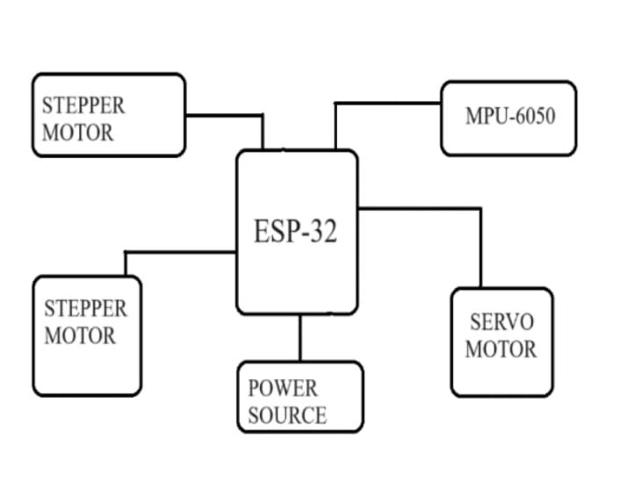
ALGORITHM:

Fig.1 BLOCK DIAGRAM

METHODOLOGY:
Hardware Setup:
- Assemble the robot chassis using the specified components.
- Connect the accelerometer and gyroscope to the ESP32.
- Connect the motor driver to the ESP32 and DC motors.
- Power the robot using the battery.
Software Development:
- Write code using the Arduino IDE or a similar development environment.
- Read sensor data from the accelerometer and gyroscope.
- Implement a control algorithm (e.g., PID control) to calculate the required motor speeds.
- Send control signals to the motor driver to adjust the motor speeds.
- Develop a user interface (e.g., a mobile app or a web interface) for interaction.

Expected Outcomes:

A functional self-balancing robot capable of maintaining equilibrium.

A well-structured and efficient control system.

A user-friendly interface for controlling the robot.

Potential for further development and applications, such as obstacle avoidance or autonomous navigation.

APPLICATION:
Personal Transportation: Devices like Segways and electric scooters rely on self-balancing technology to provide efficient and stable personal transport.
Robotics Research: Self-balancing robots are often used in academic and industrial research to study control systems, artificial intelligence, and human-robot interaction.
Entertainment and Education: Platforms like robot kits or humanoid robots use self-balancing systems to engage users in STEM education, learning about robotics and control algorithms.
Delivery Robots: Self-balancing robots can be used for small-scale delivery applications, such as transporting goods within buildings or campuses in a stable and efficient manner.
Surveillance and Security: These robots can be deployed in indoor environments (like malls or office buildings) to patrol and monitor areas, navigating around obstacles while maintaining balance.
Autonomous Vehicles: Self-balancing robots are stepping stones toward the development of advanced autonomous vehicles that require stability while navigating complex environments.
Industrial Automation: In factories or warehouses, self-balancing robots can be used for material handling, transporting items across flat surfaces efficiently without tipping over.
Entertainment and Performances: Robots with self-balancing features can perform tricks or stunts in shows and exhibitions, demonstrating advanced robotics and engineering concepts.

Conclusion:
In conclusion, the development of a Wi-Fi controlled self-balancing bot utilizing the ESP32 microcontroller presents a significant advancement in the field of robotics and IoT. Through the integration of advanced technologies, such as accelerometers, gyroscopes, and WiFi connectivity, this project offers a versatile and efficient solution for various applications.
The ESP32 microcontroller's capabilities, including its low power consumption, robust processing power, and built-in WiFi module, make it an ideal choice for controlling the self-balancing bot. By leveraging the ESP32's Wi-Fi connectivity, users can remotely control the bot from a smartphone or computer, enhancing its accessibility and usability in different environments.

